**Project Design Phase-I**

**Solution Architecture**

|  |  |
| --- | --- |
| Date | 19 September 2022 |
| Team ID | PNT2022TMID43448 |
| Project Name | Project - Deep Learning Fundus Image Analysis for Early Detection of Diabetic Retinopathy |
| Maximum Marks | 4 Marks |

**Solution Architecture:**

The main objective is to detect the Diabetic Retinopathy in early stages by processing the Retinal fundus images. We used Transfer Learning techniques like Inception V3, Resnet50, Xception V3 that are more widely used as a transfer learning method in medical image analysis and they are highly effective. Deep Learning, Machine learning, Neural Networks and knowledge in Python will play a significant role in the development of our Project.

Since the data we use are Images, the best type of neural network satisfying our goal is Convolutional Neural Networks. Before any classification, pre-processing techniques will be implemented. For this, mentioned techniques has been used to find and bold the intensity of the abnormal areas and pieces for decreasing the effect of outliers. Some of images have abnormal structures. For instance, optic disk and vessels are abnormal, using gray-scaled images reduces its effects.

Consequently, better accuracy will be achieved by pre-processed data. After doing pre-processing and normalizing, appropriate features will be extracted for the neural network to be trained on. Over this the deep NN will be trained and results will be evaluated by varying the hyperparameters.

A GUI (website) will be developed for the same. The user will be able to give his fundus image as the input, the output will be displayed as the level of severity or the stage of the disease.

[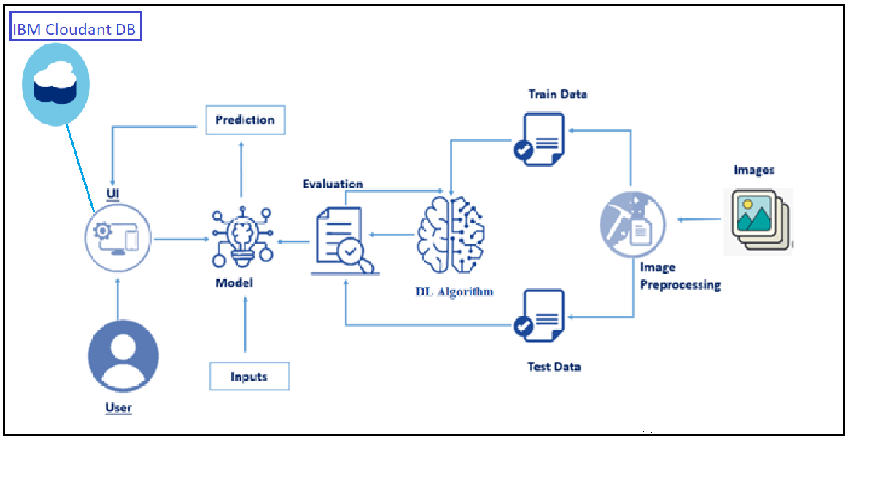](https://user-images.githubusercontent.com/78421729/190216164-f6310103-26b1-41e1-8715-4a1ac281ba89.png)